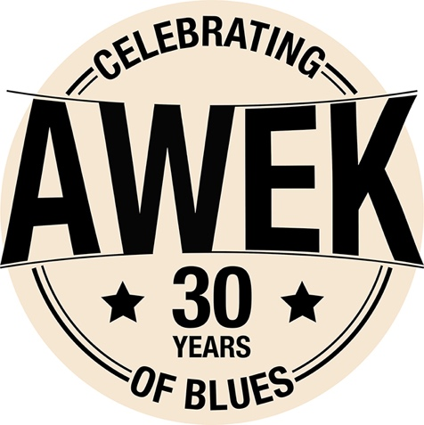

Fabrice JOUSSOT : vocals, guitars
Joël FERRON : bass
Olivier TREBEL : drums
Stéphane BERTOLINO : harmonica
With 13 albums and 30 years' experience behind them, AWEK have acquired a strength and maturity worthy of their peers on the other side of the Atlantic. Their musical style is an explosive cocktail, mingling classicism and originality.
In addition to performing across Europe, AWEK has also performed in many venues in North America, including the infamous Antone’s in Austin, Texas and the Montreal Jazz Festival. AWEK was honored as a finalist at the 2008 International Blues Challenge and in 2011 Stephane Bertolino won the prize for best harmonica player.
In 2009, AWEK was elected band of the year by Cognac Blues festival, and opened for BB KING.
In 2017 the Band released a 10 th album recorded in 3 differents studio including Wire recording (Austin TX), mixing classics and originals by the end of 2016.
Mark Hummel, Little Charlie Baty, Kid Andersen ,Fred Kaplan, Derek O’ Brien, Kaz Kazanoff, Bob Welsh, Nick Connely have recorded and played with AWEK.

"Awek sound great and play what I like ... real blues" Sugar Ray Norcia
"Awek's music here only gets better with every play" Art Tipaldi, Blues Revue Magazine

www.awekblues.com
trebeloli@sfr.fr
tel (33) 621294483

