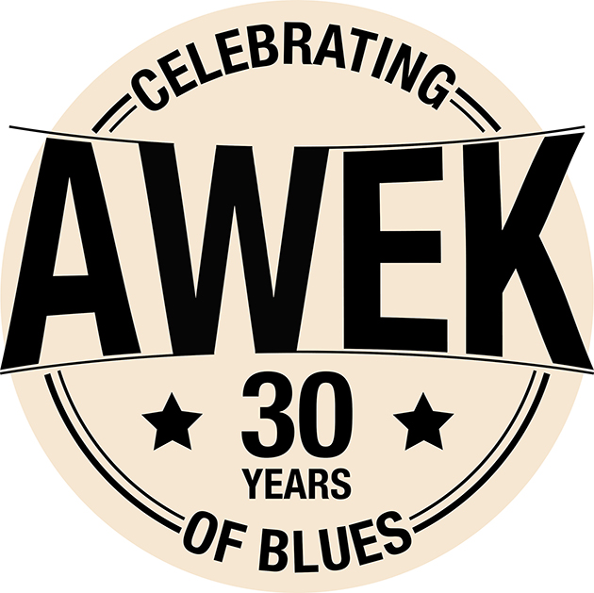
Rider
Last update september 2023
LINE UP :
• Fabrice Joussot : Guitar / Vocal
• Stéphane BERTOLINO : Harmonica
• Olivier TREBEL : Drums
• Joël FERRON : Bass
LOCATION : Toulouse – France
AWEK :
* 30 years and more than 2000 concerts throughout France, Europe, India, Morocco, Canada and the USA...
* Many festivals including the prestigious Jazz à Montréal, Jazz à Vienne, Jazz in Marciac, Cognac Blues Passions, Cahors Blues, Blues sur Seine, Nancy Jazz Pulsation
* 12 albums recorded, including four in the USA... But also :
* The "Cognac Blues Passions" prize in 2009
* Finalist of the IBC (International Blues Challenge) in Memphis in 2008.
* Award for best harmonica player at the IBC (International Blues Challenge) in Memphis in 2011.
* Performed with the Victor Hugo Franche Comté Symphony Orchestra in 2018.
* Performed at the Philharmonie de Paris with the Orchestre Pasdeloup in January 2019.
* Inducted by France Blues to the French Blues Hall Fame!

* World premiere with the Victor Hugo Franche Comté Symphony Orchestra in December 2021 (album to be released in 2022).

LES LIENS :
Official website | Facebook
YouTube channel | Teaser 2023
Listen to the album "Awek” | Press photos
PRO SPACE (videos, press kit, presentation text ...)
20 years teaser

BACKLINE : AWEK plays on its backline...
DURATION OF THE CONCERT : minimum 1 hour, maximum 2 hours.
INSTALLATION AND SOUNDCHECK : 1h
LODGES : Provide a dressing room with tables and chairs, sink and toilet. The lodge must be locked..
CATERING : provide fresh drinks (fruit juice/water) and coffee, cheese and dried fruit.
OR THE STAGE : 4 small bottles of non-carbonated water.
MERCHANDISING : Provide a lighted area inside the room with a table of about 1.50m.
ACCOMMODATION : 4 singles / provide a secure parking space near the accommodation.

CONTACTS :
Olivier Trebel | + 33 621 294 483 | trebeloli@sfr.fr
Joël Ferron | + 33 662 793 080 | info@awekblues.com

If you have a problem with any of the items requested, please let us know as soon as possible: for every problem there is a solution.

Technical Rider AWEK

Olivier Trebel
+33 621 294 483
www.awekblues.com
info@awekblues.com

1 bass drum microphone closed skin microphone type D6
2 over head for the drums
1 snare drum microphone type 57
1 Charleston microphone
2 toms microphones
1 guitar amp mic
1 harmonica amp mic
1 DI input and a microphone for bass amp
3 vocal mics
1 monitor for lead vocals/guitar (2)
1 drum monitor (4)
1 bass monitor (3)
1 harmo monitor (1)

4 monitors

Patch monitorss
In monitor 1 only the harmo microphone
In monitor 2 only the lead voice
In monitors 3 & 4 lead voice and the 2 harmo sources

No compression in the monitors. Thank you.
Drums
monitors
Harmonica
Amp

4
Bass
Amp
Guitar
Amp

micro Bass vocal
Micro harmo Micro lead
monitors
3
1
2
center
↑

